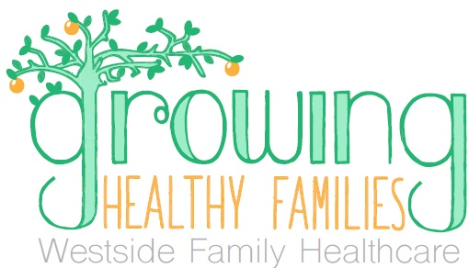

**VENDOR REQUEST FORM**

|  |  |  |  |  |
| --- | --- | --- | --- | --- |
| **Agency Name:** | | | | |
| **Contact Name/Title:** | | | | |
| **Phone:** | **Email:** | | | |
| **Address:** | | | | |
| **City:** | | **State:** | | **Zip:** |
| **I would like to particpate at**  (Choose all that apply) | | | | |
| Northeast Health Center  August 2, 2018, 3 pm – 6 pm  908 E 16th St, Wilmington, DE 19802 | | | Dover Health Center  August 23, 2018, 3 pm - 6 p.m.  1020 Forrest Avenue, Dover, DE 19904 | |

**Please provide a brief description of the service or information you will provide:­­­­­**

|  |
| --- |
|  |
|  |

**Please indicate what school supply you would like to provide to the children in attendance.**

(NOTE: approximately 300 items needed)

|  |
| --- |
|  |

**PLEASE EMAIL, FAX, OR MAIL FORM**

**Return by July 20, 2018** (one form is sufficient to participate in both events)

**Westside Family Healthcare**, External Affairs

300 Water Street, Suite 200, Wilmington, DE 19801  
Fax: 302-656-8982; Email: [externalaffairs@westsidehealth.org](mailto:externalaffairs@westsidehealth.org)